
AIN SHAMS UNIVERSITY
FACULTY OF ENGINEERING
CSE241 Object-Oriented Programming
HOTEL RESERVATION SYSTEM
Milestone 2
Project Report
Instructors:
Prof. Mahmoud Khalil
Eng. Mazen Tarek

Prepared by:
Hazem Hassan Sayed (25P0125)
Mariam Sameh Sadek (25P0396)
Rovan Nour Rashwan (23P0388)
Khaled Ahmed Mohamed (25P0408)
Date: 9/5/2026

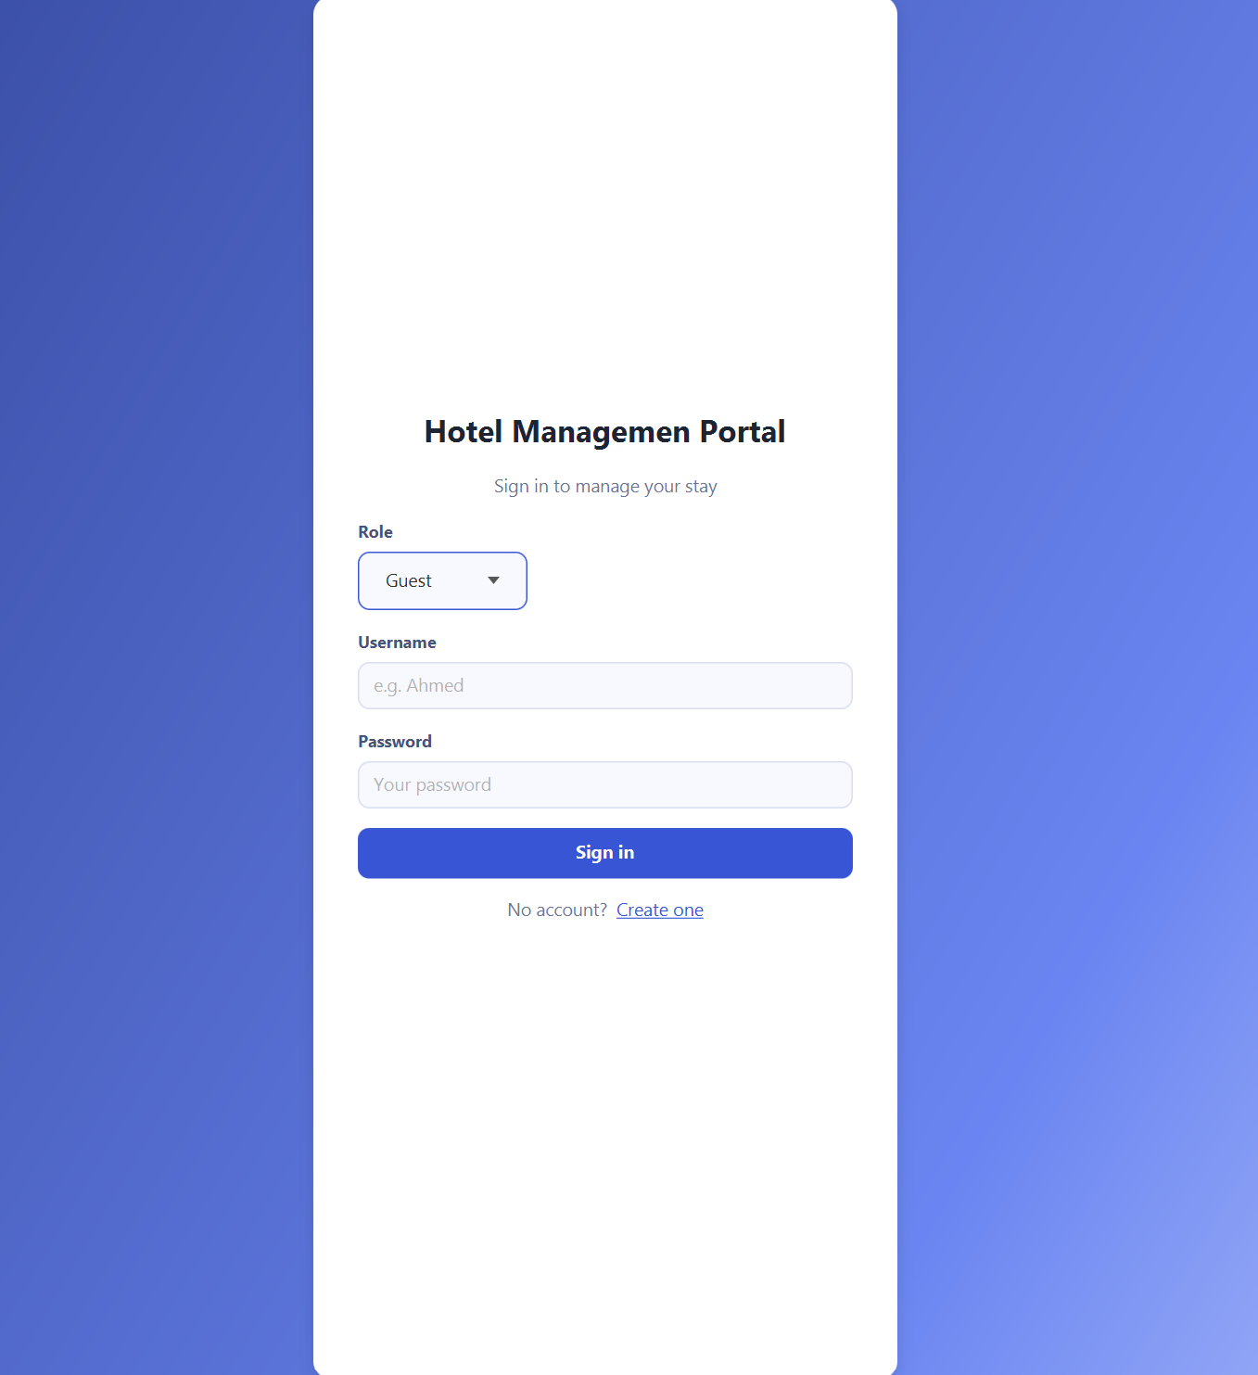
1.Login Portal

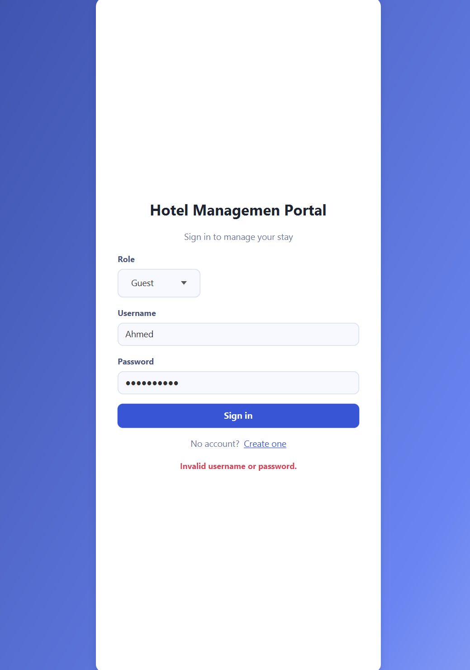
2. Invalid Username or Password Scenario

3. Duplicated Username Register Scenario
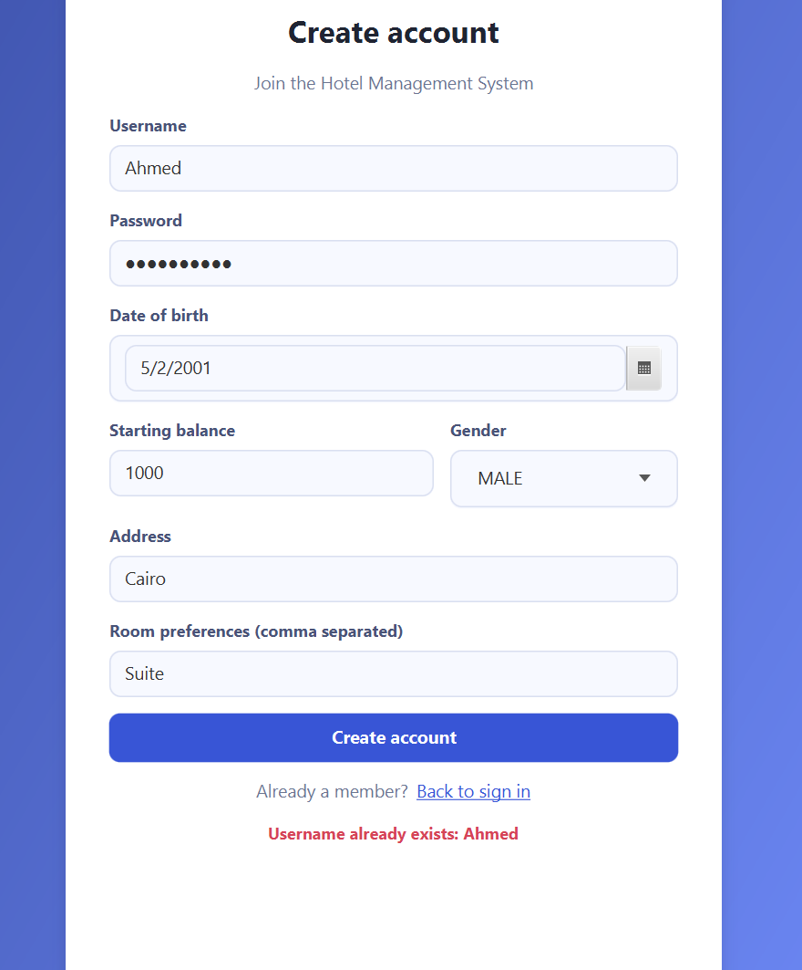

4. Guest Dashboard
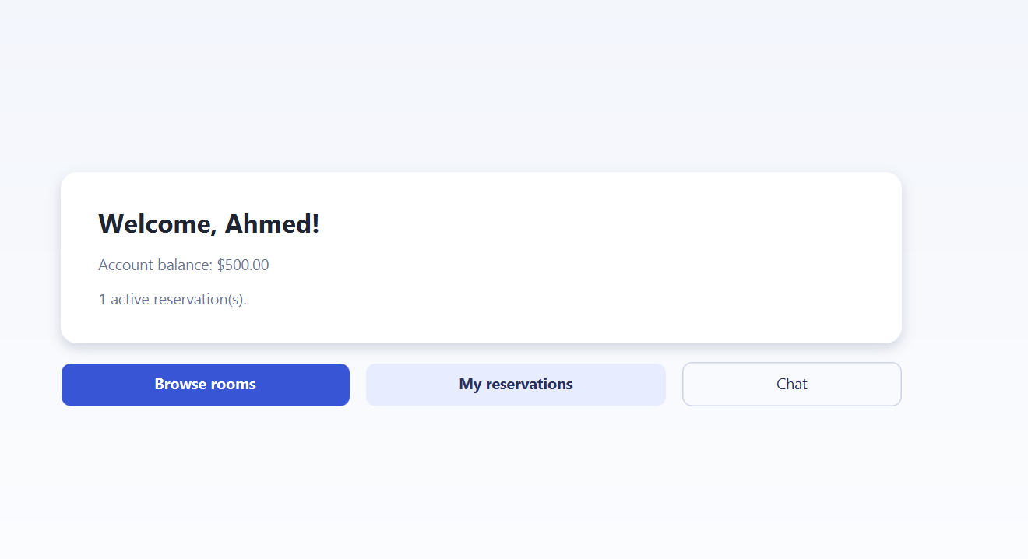

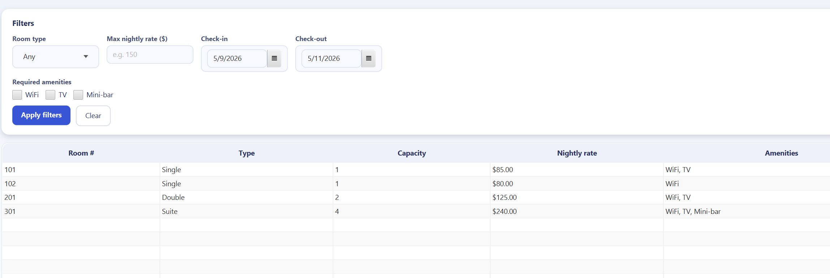
5.Room Browsing Dashboard

6.Adding Existing Room ID Scenario
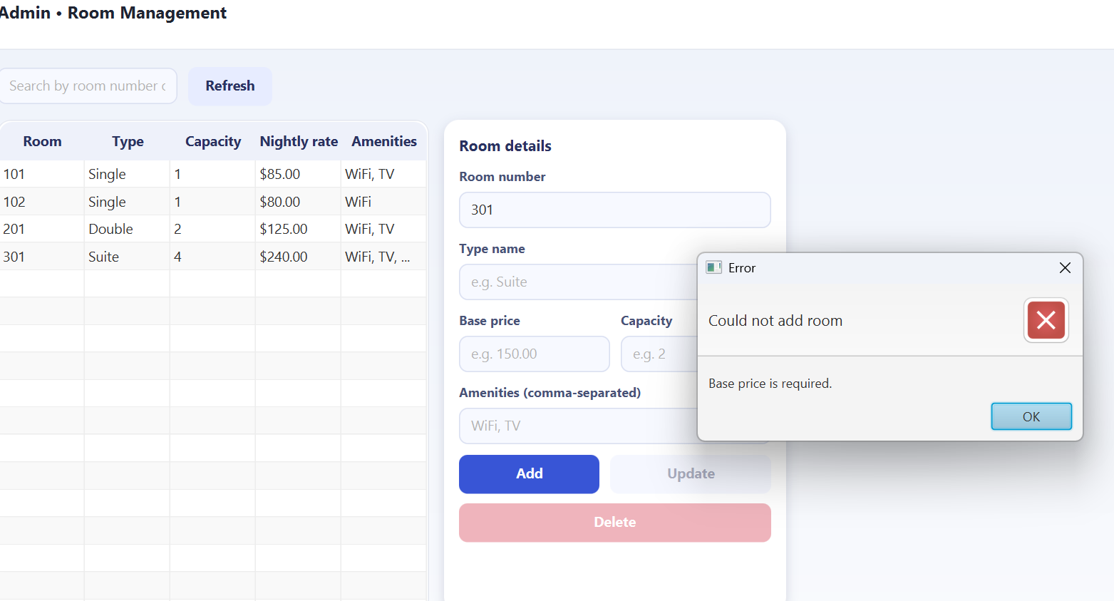

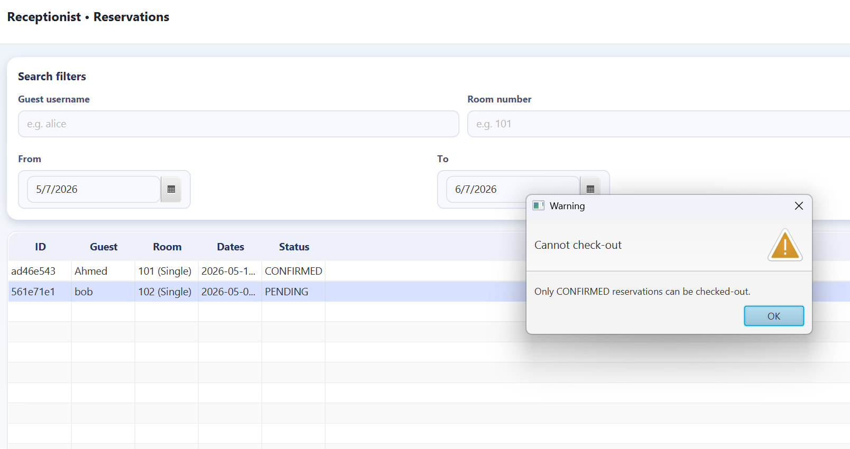
7.Checking-out Pending Reservation Scenario

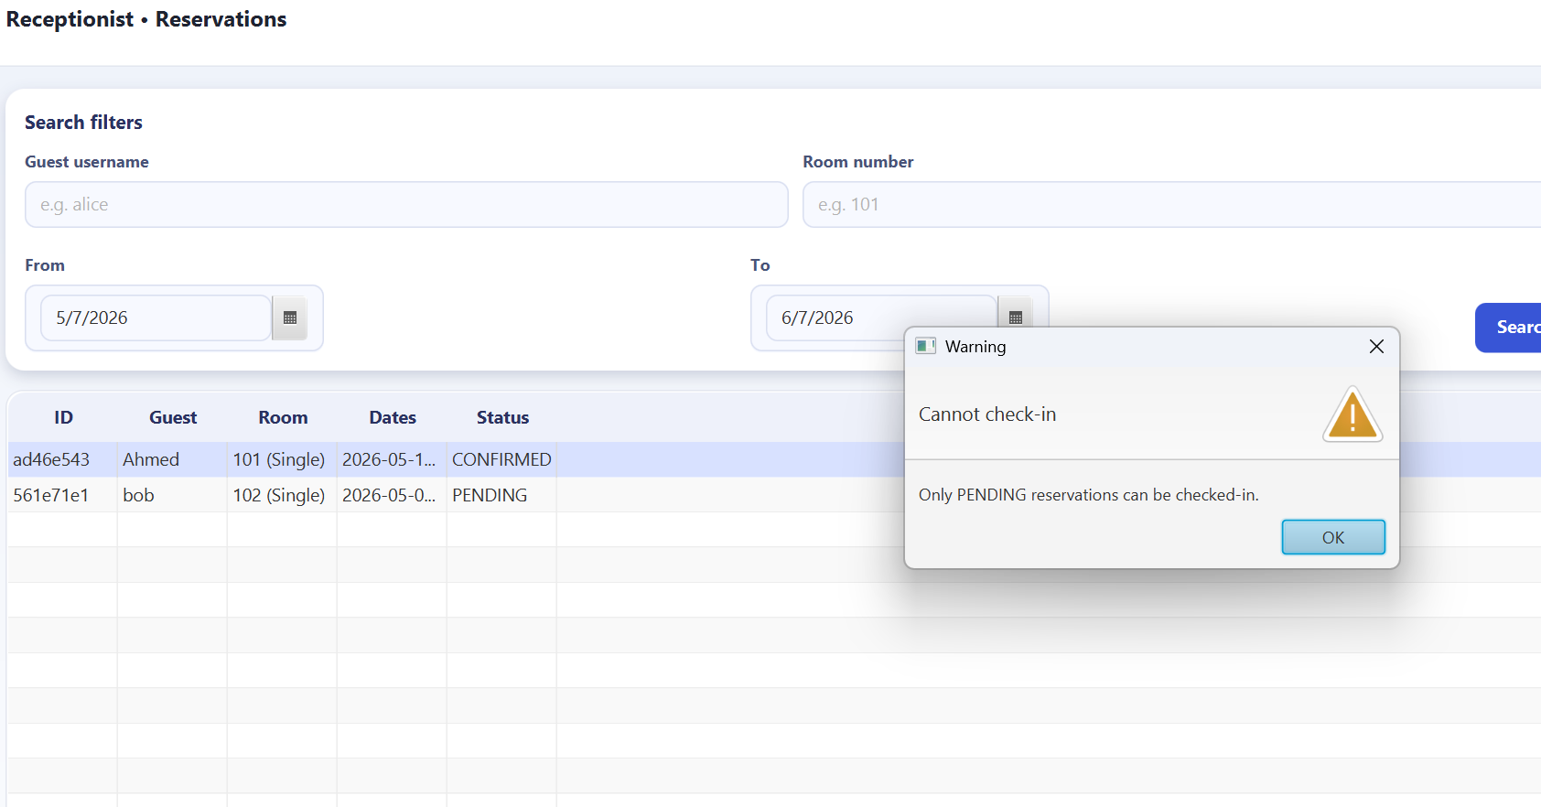
8.Checking-in Confirmed Reservations Scenario

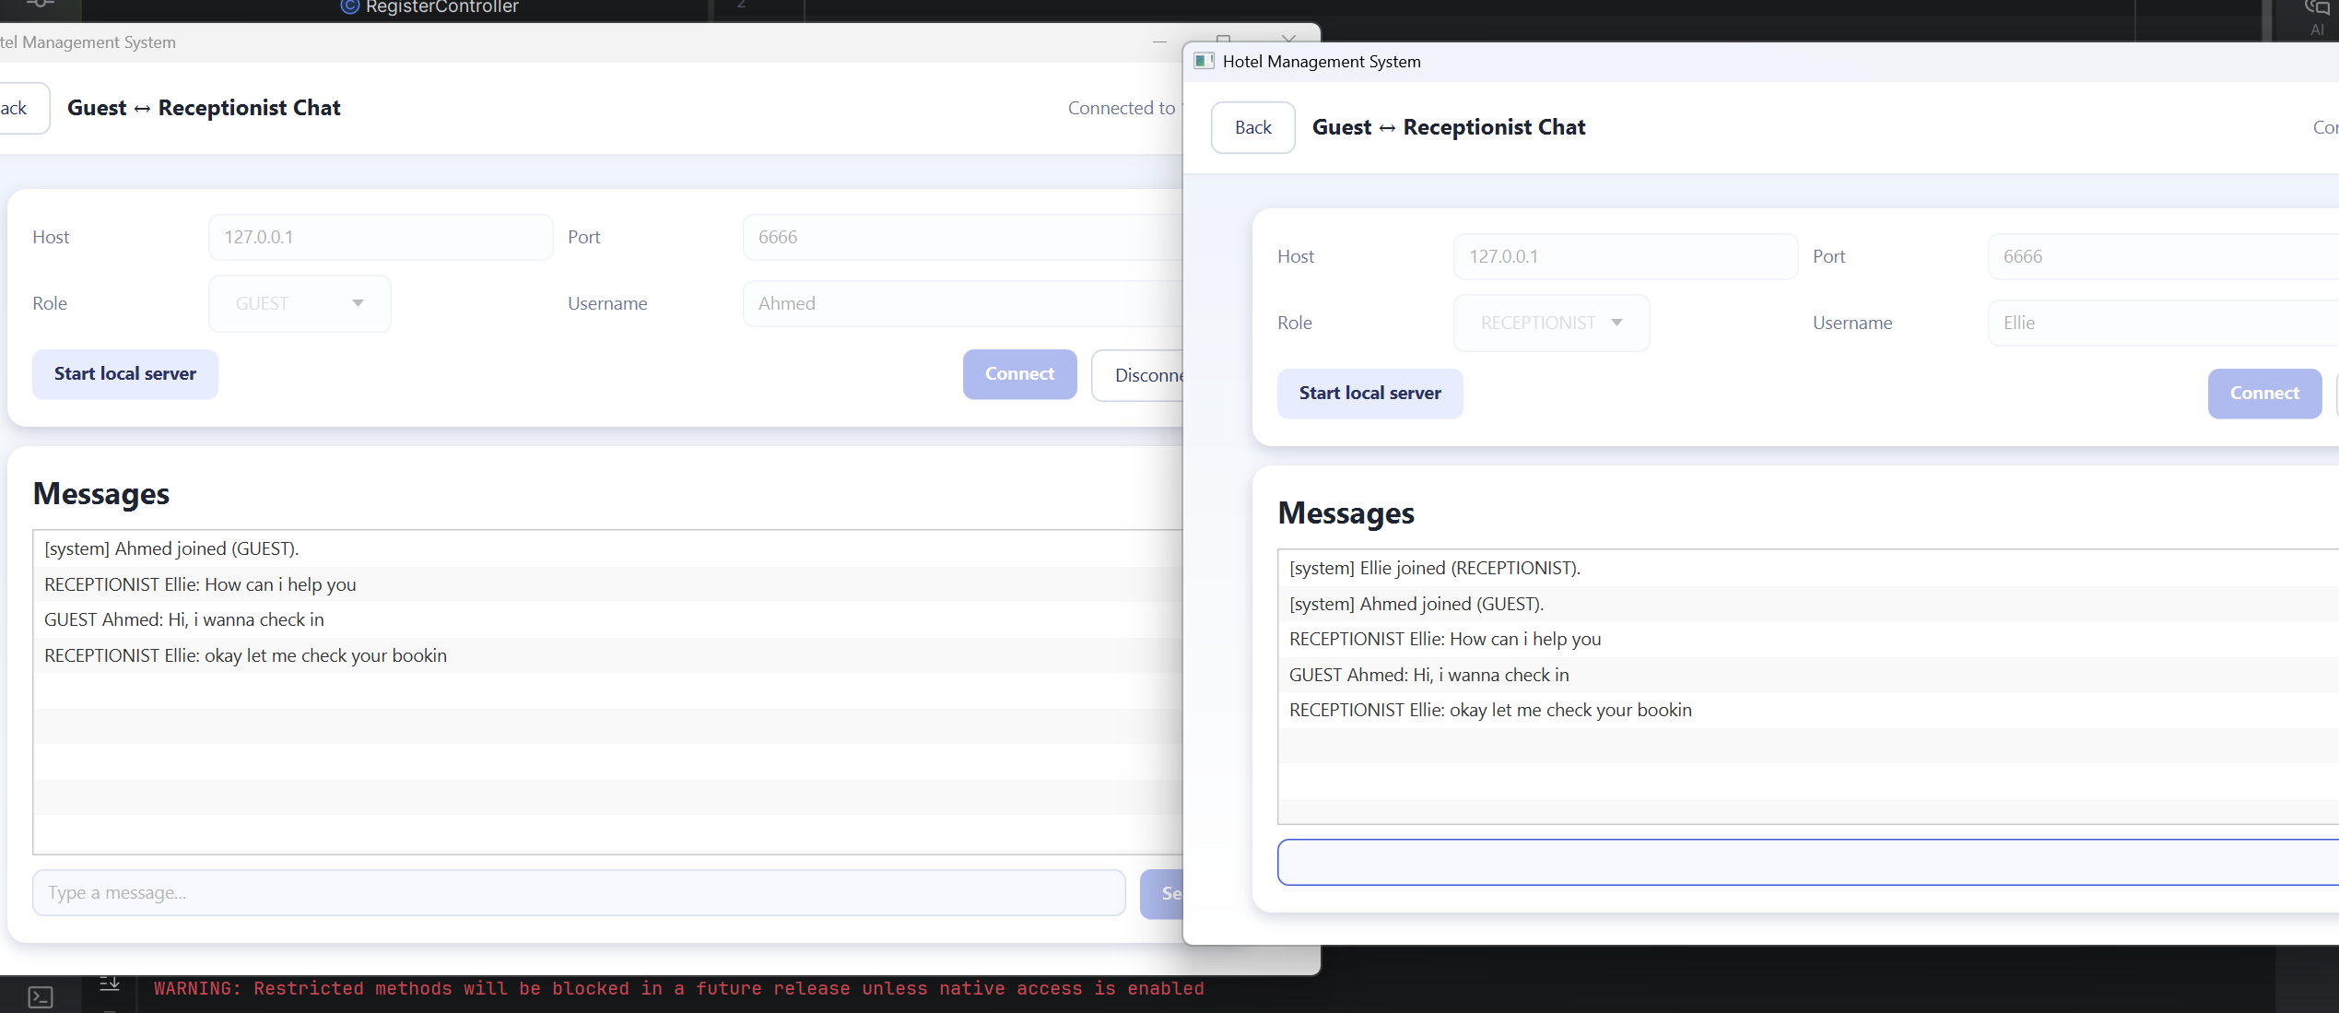
9.Live Chat

10.Paying Options

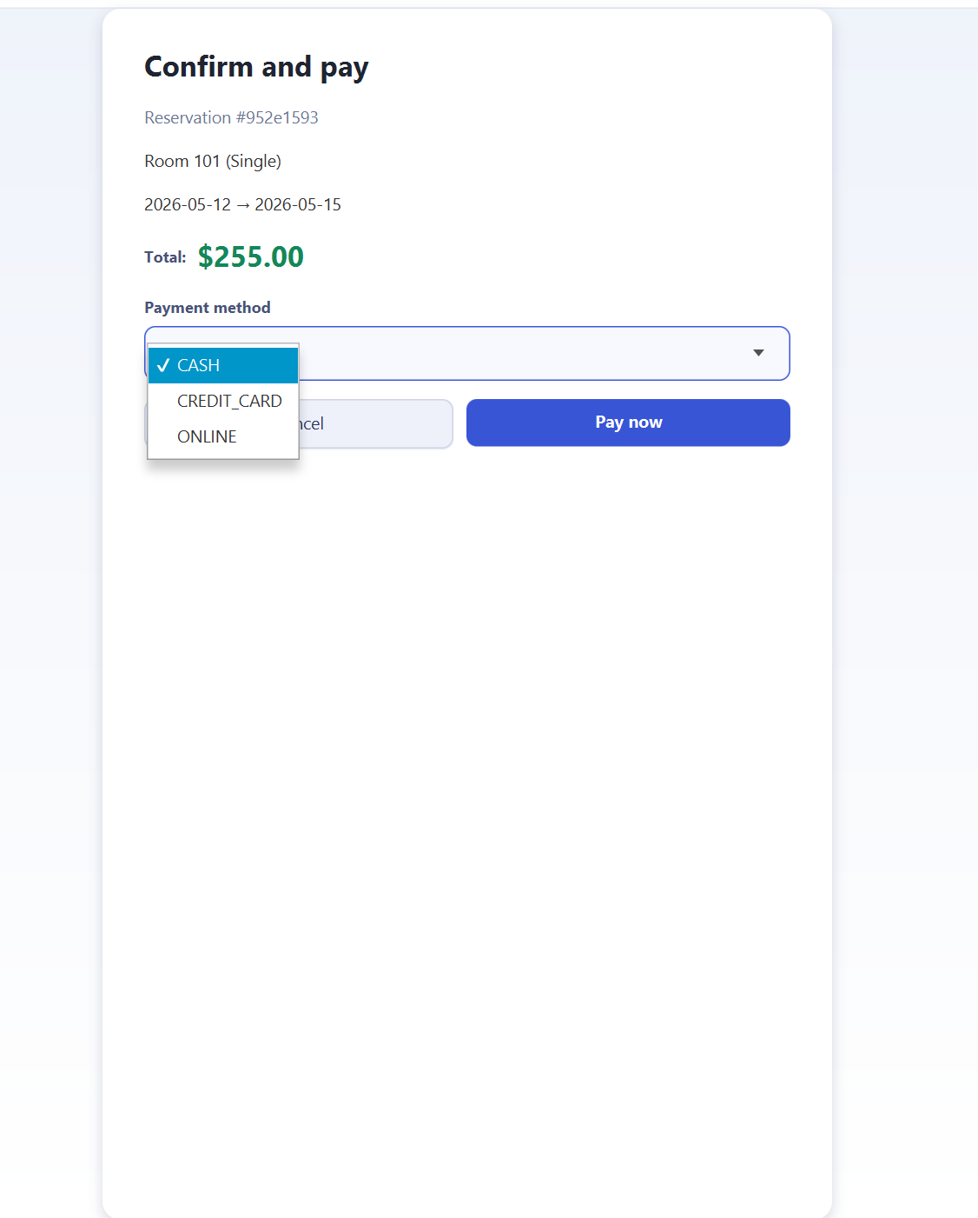

11.Paying Already paid Reservation Scenario

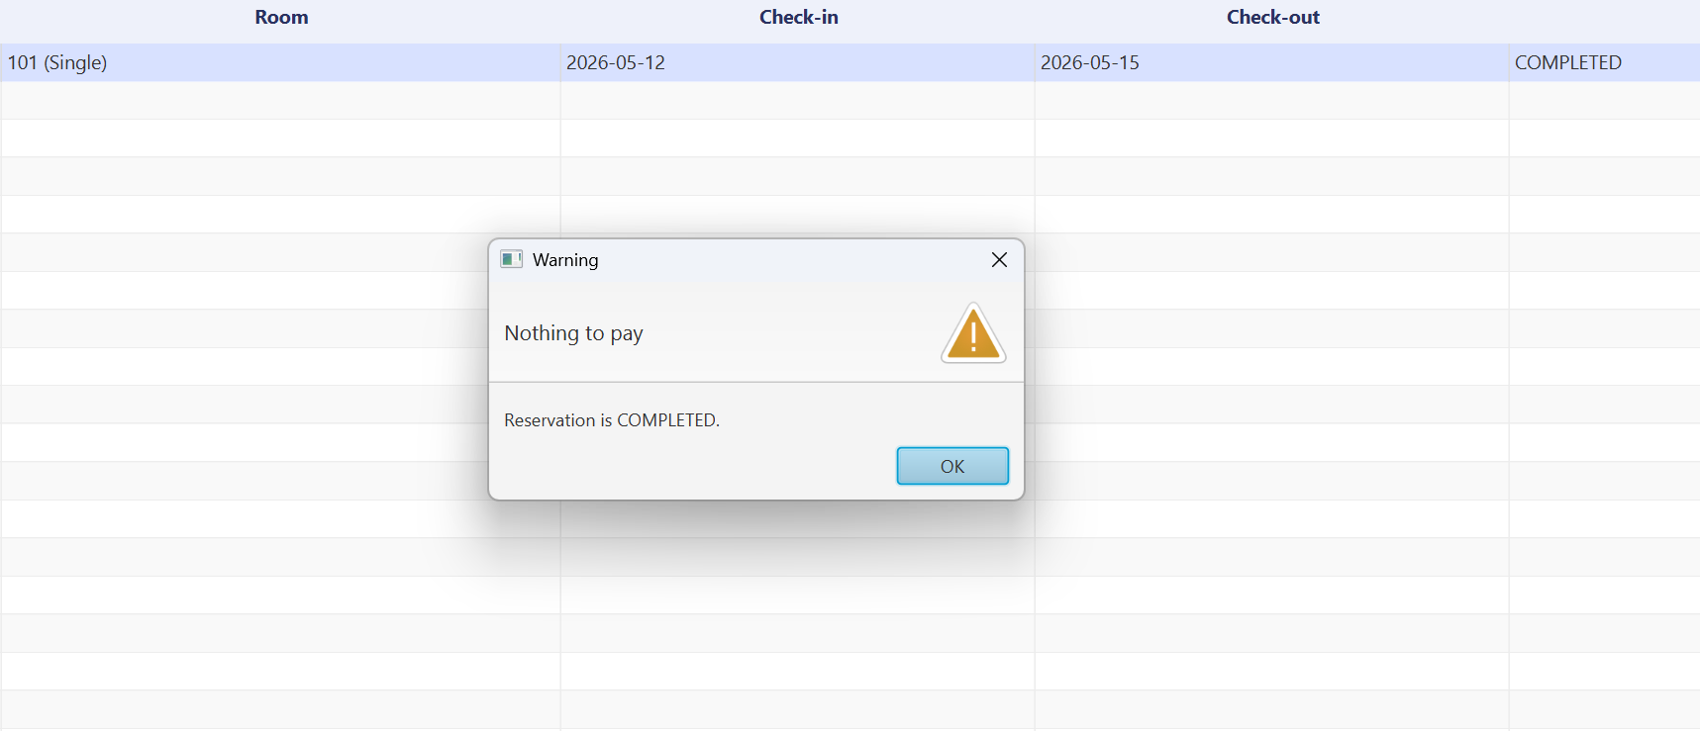

12.Succeful Paymen Scenario
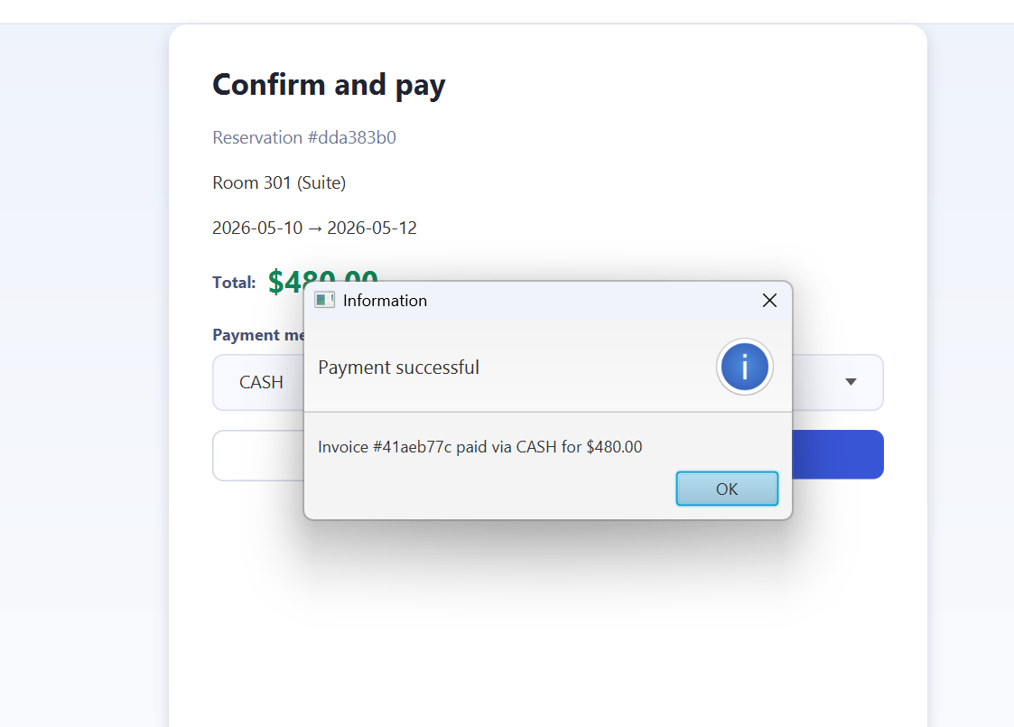

13. Github Repo and youtube Video Links

https://github.com/zoma2077/Hotel-Management-mainfinal.git
https://youtu.be/mEi_xb_zsV8?si=xfLFjbvxrSem4y3p

